Independent Study
Anomaly Imputation with Diffusion
Monday February 9, 2026

Table of Contents
1.0 Introduction 1
2.0 Architecture 1
3.0 Anomalies 2
4.0 Training Process 3
5.0 Inference Process 4
6.0 Algorithms 5

Introduction
Traditionally, imputation is the process of adding normal missing data to a dataset. A classic example is to add normal data in ECG (electrocardiogram) where data is missing. Imputation is usually necessary because the algorithms that work with ECG require a complete dataset. Diffusion models have been successfully adopted for such tasks. Additionally, given that Diffusion models have had much success in images, it has been used for image anomaly imputation. An example is adding a hole to an acorn nut at a specific location. Imputation is also sometimes referred to as inpainting.

Architecture
Essentially, the architecture takes a noisy 1D signal and a timestep as inputs. Then it learns how to remove the noise step-by-step. A UNet-shaped model is adopted with skip connections so that there is time awareness. Generally, a UNet is the traditional neural network model used for Diffusion because of the need to remove noise at many points throughout the Diffusion algorithm. The architecture performs the following:
- Looks at the noisy signal
- Knows how noisy it is at a certain point (time embedding)
- Extracts features at multiple levels
- Reuses earlier details via shortcuts (skip connections)
- Outputs the predicted noise

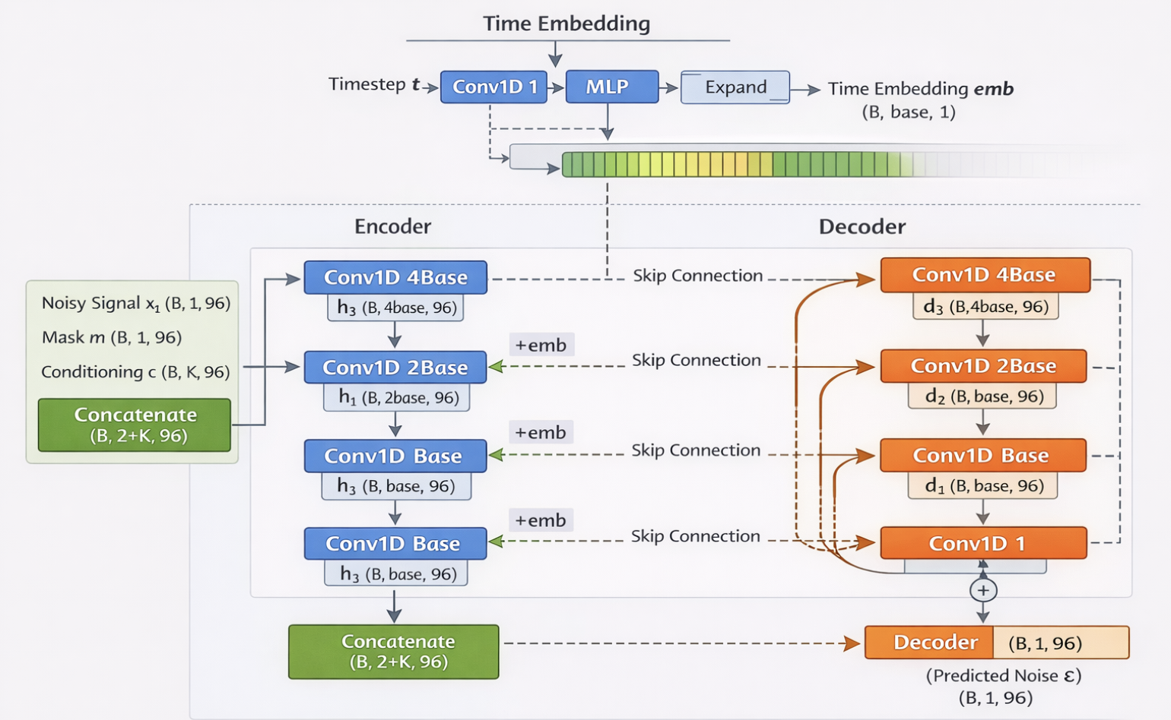

Anomalies
We synthetically create seven anomalies are per the general descriptions below.

Anomaly | Description
StepChange | A sudden, large, and sustained jump in power, mimics sensor faults or abnormal switching.
MultiStepChange | A series of abrupt power jumps simulating erratic or degrading appliance behavior.
Mirror | A segment of power data reversed mimics data corruption or reverse logging.
Repeating | Duplications simulating loops or stuck cycles in control.
StuckMAX | Continuously stuck at its highest level, simulating runaway or failed components.
StuckMIN | Continuously stuck at its lowest level, simulating sensor errors or idle-state bugs.
PowerCycling | A rapid switching on/off, simulating relay bounce, unstable power supply, or hardware faults.

Mathematically, these anomalies are described below:

- StepChange
This consists of two plateaus. First, at 30% of max height in the day, and second, at 80% height. Clip to fit the min-max range of the day.

- MultiStepChange
Between 20% and 90%, add four equally spaced plateaus. Clip to fit the min-max range of the day.

- Mirror
Reverses active power according to time.

- Repeating
Split into 5 chunks with a sinusoid having center at 50% max with amplitude of 30%. Clip to fit the min-max range of the day.

- StuckMAX
Set all values to be the max of the day.

- StuckMIN
Set all values to be the min of the day.

- PowerCycling
Alternate between max and min of the day.

Training Process
First, we extract one full day and scale to [0,1]. There are 96 points to a day corresponding to 24 hours x 4 (4 x 15 minutes) = 96. We also sample a timestamp $t∼U\{1,…,T\}$ and Gaussian noise $ε∼N(0,I)$.
Now, we perform the Forward Diffusion with the following noise schedule ($β_{i}$):

$$x_{t}=\sqrt{{\overset{ˉ}{α}}_{t}} x_{0}+\sqrt{1-{\overset{ˉ}{α}}_{t}} ε$$

$$β_{1}≈{10}^{-4},β_{T}≈2×{10}^{-2}$$
$$α_{t}=1-β_{t},{\overset{ˉ}{α}}_{t}=\prod_{s=1}^{t}{α_{s}}$$
Next, we identify the binary mask in the anomaly region. We pick a region $[s,e)$ (for your fixed middle third, $s=32,e=64$):
$$m_{i}=\left\{\begin{matrix}1 & s≤i<e \\ 0 & \text{otherwise}\end{matrix}\right.⇒m∈\{0,1\}^{96}$$
This translates to mask size being: $∣m∣=\sum_{i=1}^{96}{m_{i}}$
Next, we define the K anomaly classes (we have 7). Let the desired class be $k∈\{1,…,K\}$. Then:
$$c∈R^{K×96},c_{j,i}=\left\{\begin{matrix}m_{i} & j=k \\ 0 & j≠k\end{matrix}\right.$$
Insert synthetic anomaly inside mask: $x_{0}=x_{0}^{\text{clean}}⊙(1-m)+g_{a}(x_{0}^{\text{clean}},m)⊙m$ , whereby $g_{a}(⋅)$ is your anomaly injector and outside the mask it is your original day.
Then you do forward diffusion on this $x_{0}$ (the anomalous version):

Rearranging the Forward Process, we can calculate: $ε=\frac{x_{t}-\sqrt{{\overset{ˉ}{α}}_{t}} x_{0}}{\sqrt{1-{\overset{ˉ}{α}}_{t}}}$
Now, the neural network predicts the noise, ${\hat{ε}}_{θ}=ε_{θ}(x_{t},t,m,c)$, given the inputs of time/mask/class.
The masked noise is: $L_{ε}={∥(ε-{\hat{ε}}_{θ})⊙m∥}_{2}^{2}$ , expanded to: $L_{ε}=\sum_{i=1}^{96}{m_{i}} (ε_{i}-{\hat{ε}}_{θ,i})^{2}$
The reconstructed signal is: ${\hat{x}}_{0}=\frac{x_{t}-\sqrt{1-{\overset{ˉ}{α}}_{t}} {\hat{ε}}_{θ}}{\sqrt{{\overset{ˉ}{α}}_{t}}}$

Hence the masked reconstruction is: $L_{x_{0}}={∥\left({\hat{x}}_{0}-x_{0}\right)⊙m∥}_{2}^{2}$ , expanded to: $L_{x_{0}}=\sum_{i=1}^{96}{m_{i}} ({\hat{x}}_{0,i}-x_{0,i})^{2}$

The Gradient loss is:
$$L_{∇}=\sum_{i=1}^{95}{m_{i}^{∇}} ∣(∇{\hat{x}}_{0})_{i}-(∇x_{0})_{i}∣$$
$\left(∇x)_{i}=x_{i+1}-x_{i}, \right.$ $m_{i}^{∇}=m_{i} m_{i+1}$

The Total Loss is: $L=L_{ε}+0.5 L_{x_{0}}+0.55 L_{∇}$ . 0.5 and 0.55 were chosen empirically.

In summary,
  - Noise loss: learn how to remove noise
  - Reconstruction loss: get the right values back
  - Gradient loss: keep changes smooth and realistic

Inference Process
We begin by selecting a clean daily signal scaled to [0,1]: $x_{0}^{\text{clean}}∈R^{96}$.

Mirror is a special anomaly as it is not readily created with diffusion. Hence, we force the mirror behaviour in inference with the function “rev” which just reverses (mirrors) the dataset in that space.

Next, we force the values inside the mask location to be Gaussian and outside the mask to be the clean signal:

$$x_{T}=x_{0}^{\text{clean}}⊙(1-m)+z⊙m$$

We now have two predictions to accomplish. One with the anomaly class (“c”) and one without class (“u”)

$${\hat{ε}}_{c}=ε_{θ}(x_{t},t,m,c) \\ {\hat{ε}}_{u}=ε_{θ}(x_{t},t,m,0)$$

Hence, we have the Classifier-Free Guidance (CFG) as: $\hat{ε}={\hat{ε}}_{u}+w({\hat{ε}}_{c}-{\hat{ε}}_{u})$, $w=3$ (a common value)

Essentially, CFG Performs the following: Trains the diffusion model to handle both conditional and unconditional (class or non-class). It randomly drops the conditioning during training, then at inference steers generation toward a desired anomaly type by amplifying the difference between conditional and unconditional noise predictions. It is a training-and-inference strategy that teaches the same model to operate with and without conditioning, then uses the difference between those two behaviors to actively steer generation at inference time. This is a standard process for diffusion models to provide a guidance mechanism to help control generation.

The reverse Diffusion step (DDPM reverse) removes a small amount of noise at each step:
$$x_{t-1}=\frac{1}{\sqrt{α_{t}}}\left(x_{t} − \frac{1-α_{t}}{\sqrt{1-{\overset{ˉ}{α}}_{t}}} \hat{ε}\right)+σ_{t}z, z∼N(0,I)$$
$$α_{t}=1-β_{t},{\overset{ˉ}{α}}_{t}=\prod_{s=1}^{t}{α_{s}}$$
At each reverse step, we enforce locality meaning that we guarantee that values outside the mask are unchanged: $x_{t-1}=x_{t-1}⊙m+x_{0}^{\text{clean}}⊙(1-m)$

Finally, we unscale from [0,1] to the raw initial range: $x_{\text{anom}}=\text{unscale}(x_{0}^{\text{anom}})$.

Algorithms
Training Algorithm
Description | Equation
Extract one full day (96 samples) and scale to $\left[0 , 1\right]$ | $$x_{0}∈R^{96}$$
Sample diffusion timestep | $$t∼U\{1,…,T\}$$
Sample Gaussian noise | $$ε∼N(0,I)$$
Forward diffusion | $$x_{t}=\sqrt{{\overset{ˉ}{α}}_{t}} x_{0}+\sqrt{1-{\overset{ˉ}{α}}_{t}} ε$$  $$ε=\frac{x_{t}-\sqrt{{\overset{ˉ}{α}}_{t}} x_{0}}{\sqrt{1-{\overset{ˉ}{α}}_{t}}}$$
Define binary mask (anomaly region) | $$m∈\{0,1\}^{96}$$
Provide anomaly conditioning map | $$c∈R^{K×96}$$
Insert synthetic anomaly inside mask | $$x_{0}=x_{0}^{\text{clean}}⊙(1-m)+g_{a}(x_{0}^{\text{clean}},m)⊙m$$  $$x_{0}^{\text{clean}} is the original signal, g_{a} is the anomaly injection$$  Jitter is applied to the inserted anomaly
Predict noise with denoiser | $${\hat{ε}}_{θ}(x_{t},t,m,c)$$
Masked noise loss | $$L_{ε}=∥(ε-{\hat{ε}}_{θ})⊙m∥_{2}^{2}$$
Reconstruct clean signal | $${\hat{x}}_{0}=\frac{x_{t}-\sqrt{1-{\overset{ˉ}{α}}_{t}}{\hat{ε}}_{θ}}{\sqrt{{\overset{ˉ}{α}}_{t}}}$$
Masked reconstruction loss | $$L_{x_{0}}=∥({\hat{x}}_{0}-x_{0})⊙m∥_{2}^{2}$$
Gradient loss | $$L_{∇}=\sum_{i=1}^{95}{m_{i}^{∇}} ∣(∇{\hat{x}}_{0})_{i}-(∇x_{0})_{i}∣$$  $\left(∇x)_{i}=x_{i+1}-x_{i}, \right.$ $m_{i}^{∇}=m_{i} m_{i+1}$
Total loss | $$L=L_{ε}+0.5 L_{x_{0}}+0.55 L_{∇}$$

Inference Algorithm
Description | Equation
Select target day and scale | $$x_{0}^{\text{clean}}$$
Initialize noisy signal inside mask | If mirror:  $$x_{T}=x_{0}^{\text{clean}}⊙\left(1-m\right)+\text{rev}\left(x_{0}^{\text{clean}}\right)⊙m$$  Else:  $$x_{T}=x_{0}^{\text{clean}}⊙(1-m)+z⊙m$$  $$z∼N(0,I)$$
Conditional & unconditional predictions | $${\hat{ε}}_{c},{\hat{ε}}_{u}$$
Classifier-free guidance | $$\hat{ε}={\hat{ε}}_{u}+w({\hat{ε}}_{c}-{\hat{ε}}_{u})$$
Reverse DDPM step | $$x_{t-1}=\frac{1}{\sqrt{α_{t}}}\left(x_{t} − \frac{1-α_{t}}{\sqrt{1-{\overset{ˉ}{α}}_{t}}}\hat{ε}\right)+σ_{t}z$$
Enforce locality (hard constraint) | $$x_{t-1}=x_{t-1}⊙m+x_{0}^{\text{clean}}⊙(1-m)$$
If mirror | $$x_{t-1}[s:e]←\text{rev}(x_{0}^{\text{clean}}[s:e])$$
Repeat for $t=T→1$ | —
Unscale to raw units | $$x_{\text{anom}}=\text{unscale}(x_{0})$$

Images
